8th FRENCH CONGRESS ON SOCIAL AND ENVIRONMENTAL ACCOUNTING
(8th CSEAR France Conference) : June 2–3, 2025
Practical info

Conference venue : IUT de Paris - Rives de Seine

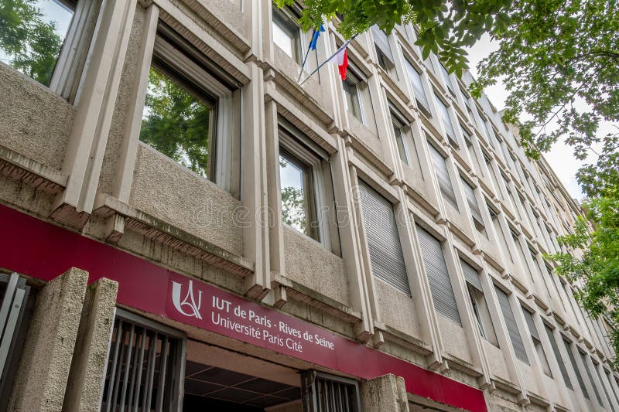

Adress : 143, avenue de Versailles 75016 Paris
> How to get there:
Bus : lines n° 22 - 62 - 72 - PC 1 - stations: Victorien Sardou, Wilhem, Versailles-Exelmans
Metro : lines 9 – 10 - stations : Église d'Auteuil, Mirabeau, Exelmans, Chardon-Lagache
Tramway : line 3a - station : Pont du Garigliano
RER : RER C Invalides/Versailles - station : Pont du Garigliano

Gala dinner : Restaurant Quai Ouest

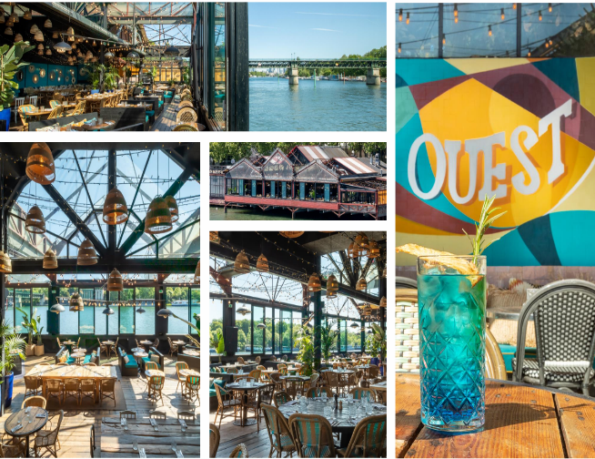 | 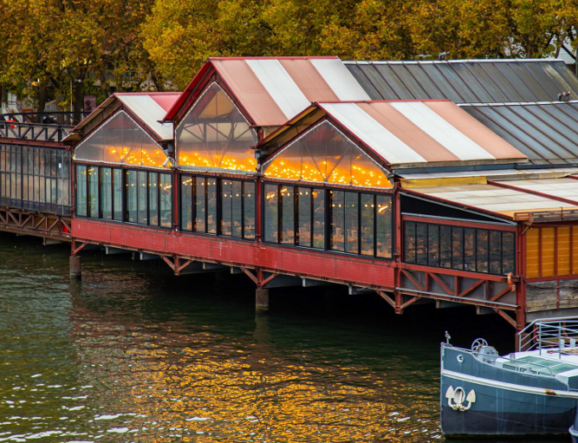
Address : 1200, quai Marcel Dassault 92210 Saint-Cloud
> How to get there from the IUT:
Metro : line 10 - station : Boulogne - Pont de Saint-Cloud
Tramway : line T2 - station : Les Milons

